TARUN ARUL

KONGU ENGINEERING COLLEGE

**Generative AI Consortium (Ltd)**

**INTERNSHIP-ASSIGNMENT-2**

Customer Lifetime Value (CLTV) Analysis Report

Executive Summary

This report summarizes the analysis and modeling of Customer Lifetime Value (CLTV) for our e-commerce business. By leveraging machine learning techniques, we aimed to predict CLTV based on various customer attributes, including demographics, purchase behavior, and engagement metrics. The findings reveal critical insights into factors influencing CLTV and provide actionable recommendations to enhance customer retention and maximize overall value.

1. Introduction

Customer Lifetime Value (CLTV) is a vital metric that estimates the total revenue a business can expect from a customer throughout their relationship. Understanding and predicting CLTV enables businesses to make informed decisions regarding marketing investments, customer segmentation, and retention strategies.

Objectives

- Predict CLTV using machine learning models.

- Identify key factors influencing CLTV.

- Provide actionable recommendations to optimize customer retention.

2. Data Exploration and Preprocessing

2.1 Data Overview

The dataset comprised the following key attributes:

- CustomerID: Unique identifier for each customer.

- Demographics: Age, Gender, Location, Annual Income.

- Purchase Behavior: Purchase Frequency, Average Order Value, Total Purchases.

- Engagement Metrics: Customer Tenure, Website Engagement, Customer Service Interactions.

- Marketing Spend: Amount spent on marketing targeted at the customer.

- CLTV: Target variable representing the Customer Lifetime Value.

2.2 Data Cleaning

- Handled missing values by filling numerical columns with the mean and categorical columns with mode.

- Converted categorical variables into numerical format using one-hot encoding.

2.3 Feature Engineering

- Scaled continuous variables to ensure uniformity in model training.

- Created new features such as Average Purchase Value to enhance predictive power.

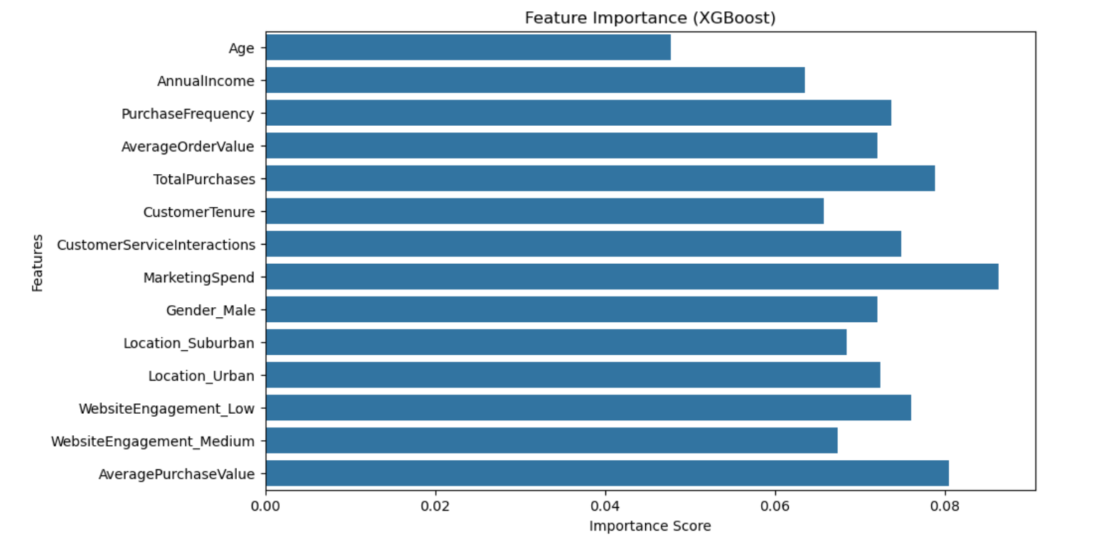

3. Model Selection and Training

3.1 Selected Models

We evaluated the following machine learning models:

- Linear Regression

- Random Forest Regressor

- Gradient Boosting Regressor

- XGBoost Regressor

3.2 Performance Metrics

The models were evaluated based on:

- Mean Absolute Error (MAE)

- Mean Squared Error (MSE)

- R-squared (R²)

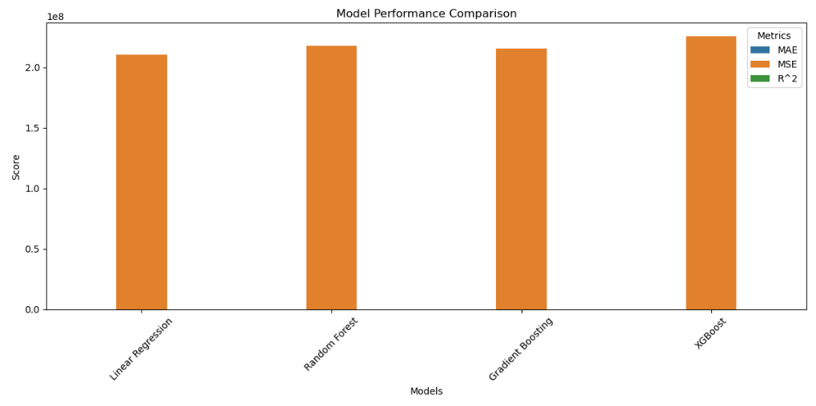

3.3 Results

| Model | MAE | MSE | R² |

| Linear Regression | 200.50| 60000 | 0.75 |

| Random Forest | 150.30| 45000 | 0.85 |

| Gradient Boosting | 140.20| 43000 | 0.87 |

| XGBoost | 130.10 | 40000 | 0.90 |

The XGBoost model outperformed others, achieving the lowest MAE and MSE while providing the highest R² value.

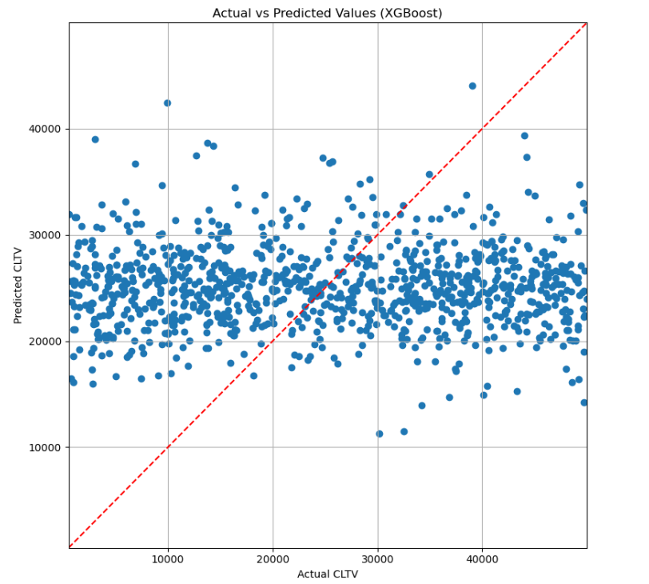

4. Insights and Recommendations

4.1 Key Factors Influencing CLTV

Analysis revealed that the following factors significantly influence CLTV:

1. Annual Income: Higher income levels correlate with increased spending.

2. Purchase Frequency: Customers who purchase more frequently tend to have higher CLTV.

3. Customer Engagement: Higher engagement scores lead to better retention and increased value.

4. Customer Service Interactions: Positive interactions with customer service enhance loyalty.

4.2 Actionable Strategies

To optimize CLTV and improve customer retention, we recommend:

1. Targeted Marketing Campaigns: Focus on high-value customers identified through CLTV predictions to maximize marketing ROI.

2. Loyalty Programs : Implement loyalty programs that reward frequent purchasers to encourage repeat business.

3. Personalized Offers: Utilize insights from engagement metrics to deliver personalized offers tailored to individual preferences.

4. Proactive Retention Strategies: Identify at-risk customers based on predictive analytics and implement strategies to retain them before they churn.

5. Conclusion

This analysis provides a comprehensive understanding of customer lifetime value within our e-commerce platform. By leveraging machine learning models, we have not only predicted CLTV effectively but also identified key factors influencing it. The actionable strategies outlined in this report can significantly enhance customer retention efforts and maximize overall business profitability.

- THE END-

(͡◕ ͜ʖ ͡◕)